**Ideation Phase**

**Define the Problem Statements**

|  |  |
| --- | --- |
| Date | 28 June 2025 |
| Team ID | LTVIP2025TMID59203 |
| Project Name | EDUCATIONAL ORGANISATION USING SERVICENOW |
| Maximum Marks |  |

**Customer Problem Statement Template:**

Create a problem statement to understand the needs and challenges of your students, faculty, or administrative staff. The Educational Problem Statement template helps you focus on what matters most to improve the academic and operational experience across your institution. A well-articulated problem statement enables your team to identify the ideal solutions for the issues faced by the educational community. By leveraging ServiceNow’s capabilities—such as workflow automation, case management, and self-service portals—you can track, resolve, and continuously improve on key challenges. Throughout the process, you’ll build empathy with users and gain clearer insight into how they experience your institution's services and systems.

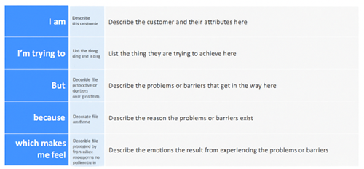

**Example:**

